Exercise 1: Implementing the Singleton
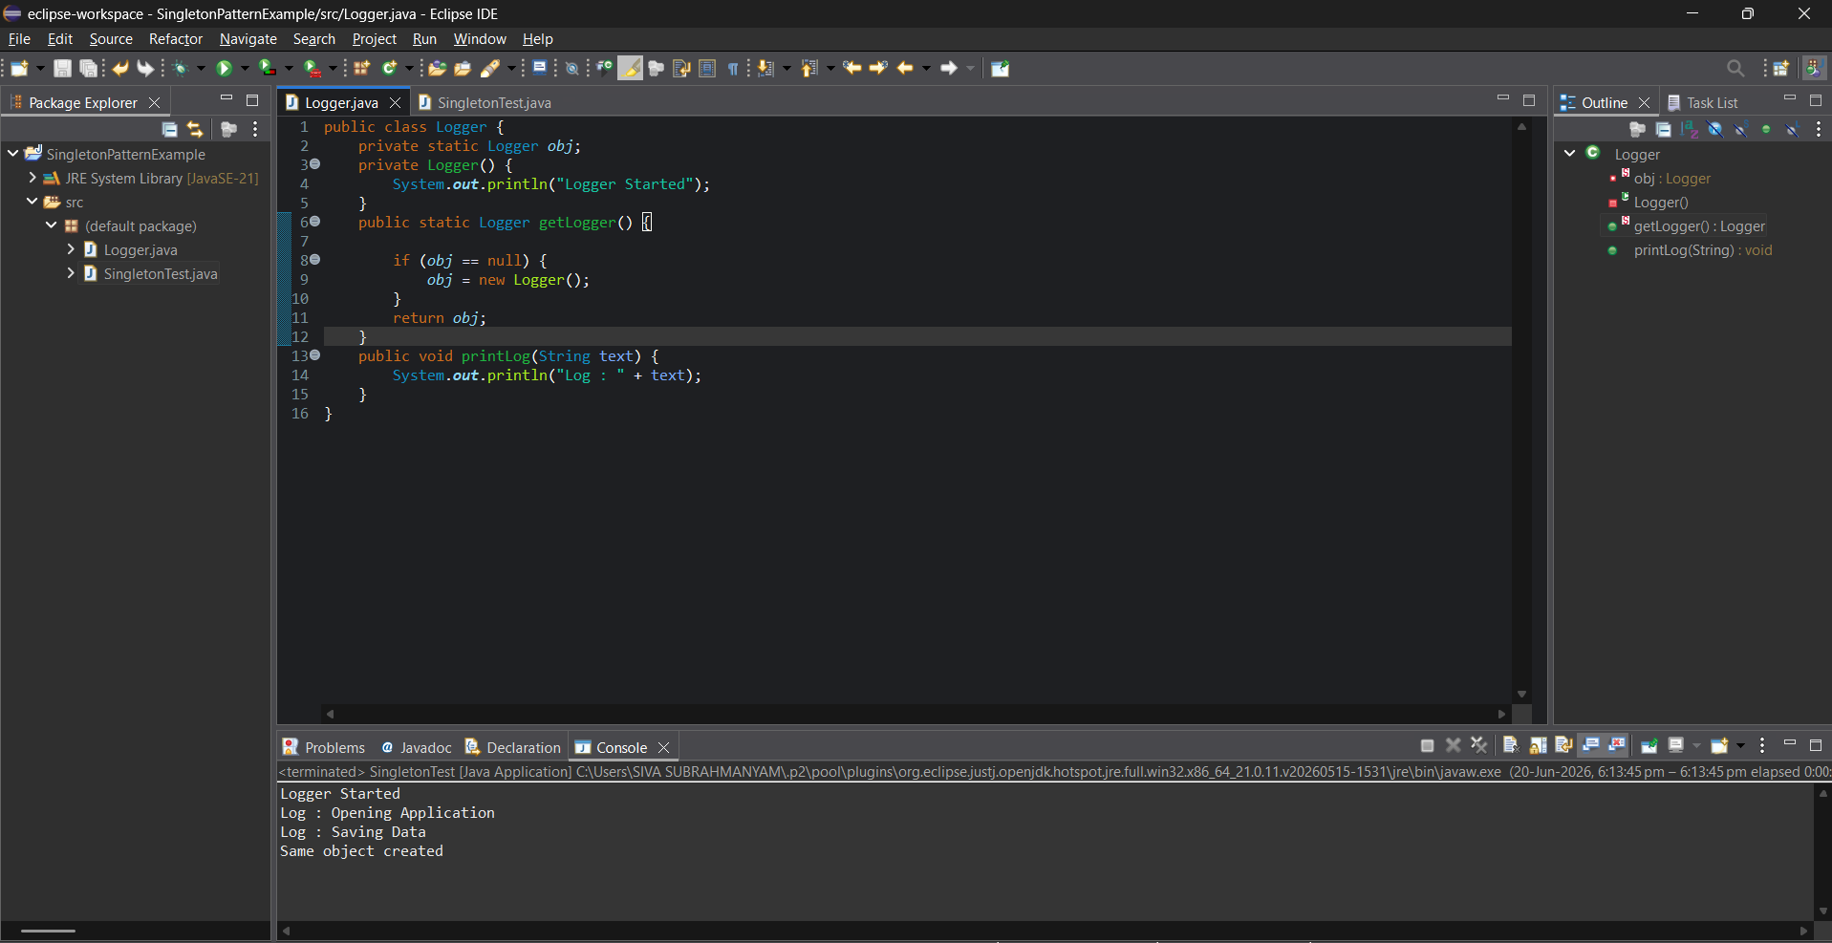
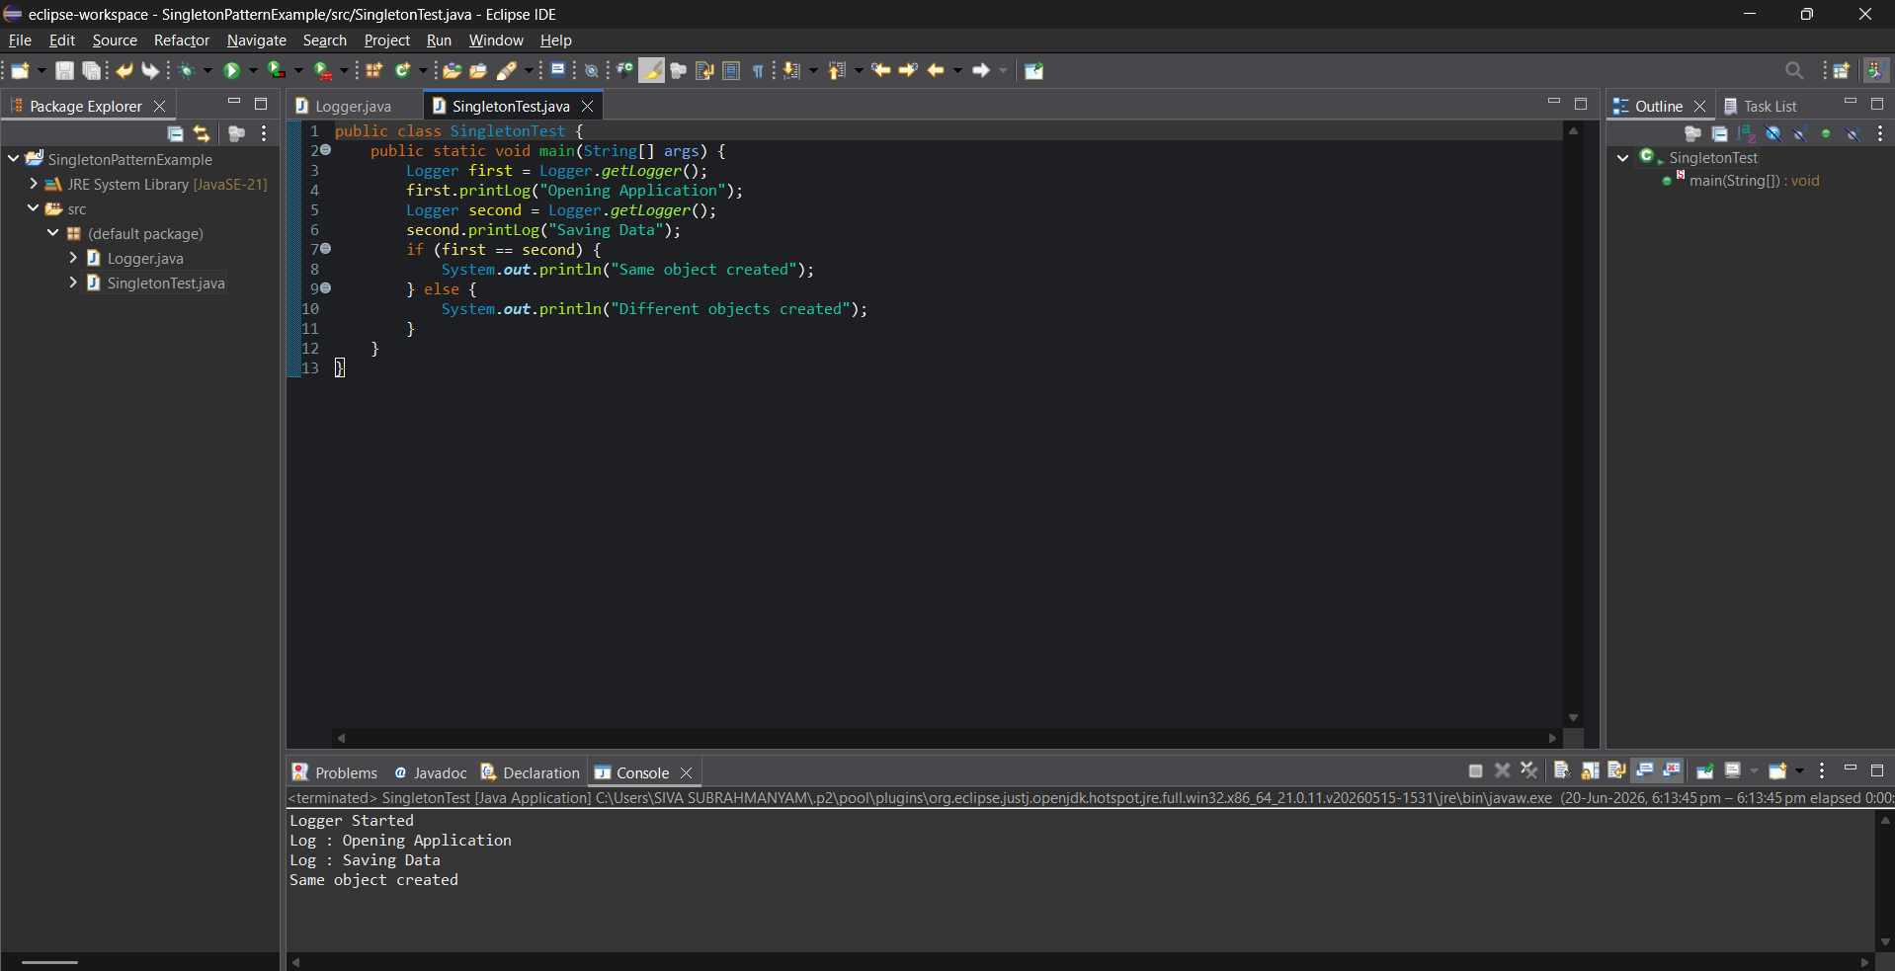
Description:
In this program, the Singleton Design Pattern is used to make sure only one object of the Logger class is created during the execution of the application. Since logging should be handled from a single place, multiple objects are avoided by making the constructor private and providing a method to access the same object whenever required. This helps maintain consistent logging and efficient memory usage.

Exercise 2: Implementing the Factory Method Pattern
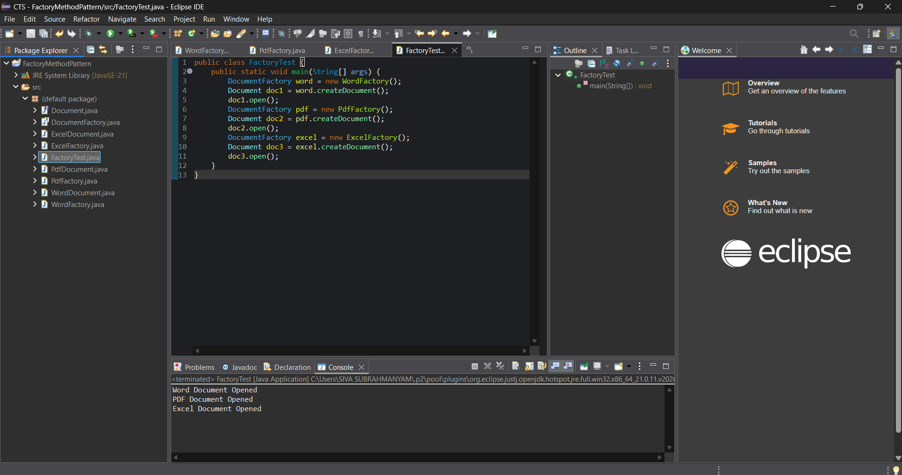

Description:
In this program, the Factory Method Design Pattern is implemented to create different types of documents such as Word, PDF, and Excel. Instead of creating objects directly, separate factory classes are used to generate the required document objects. This makes the program more organized and flexible because new document types can be added later without changing the existing code structure.

Exercise 3: Implementing the Builder Pattern
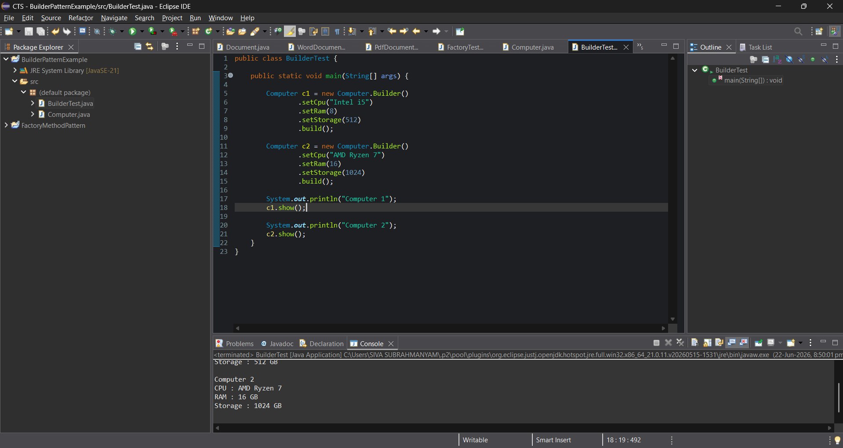
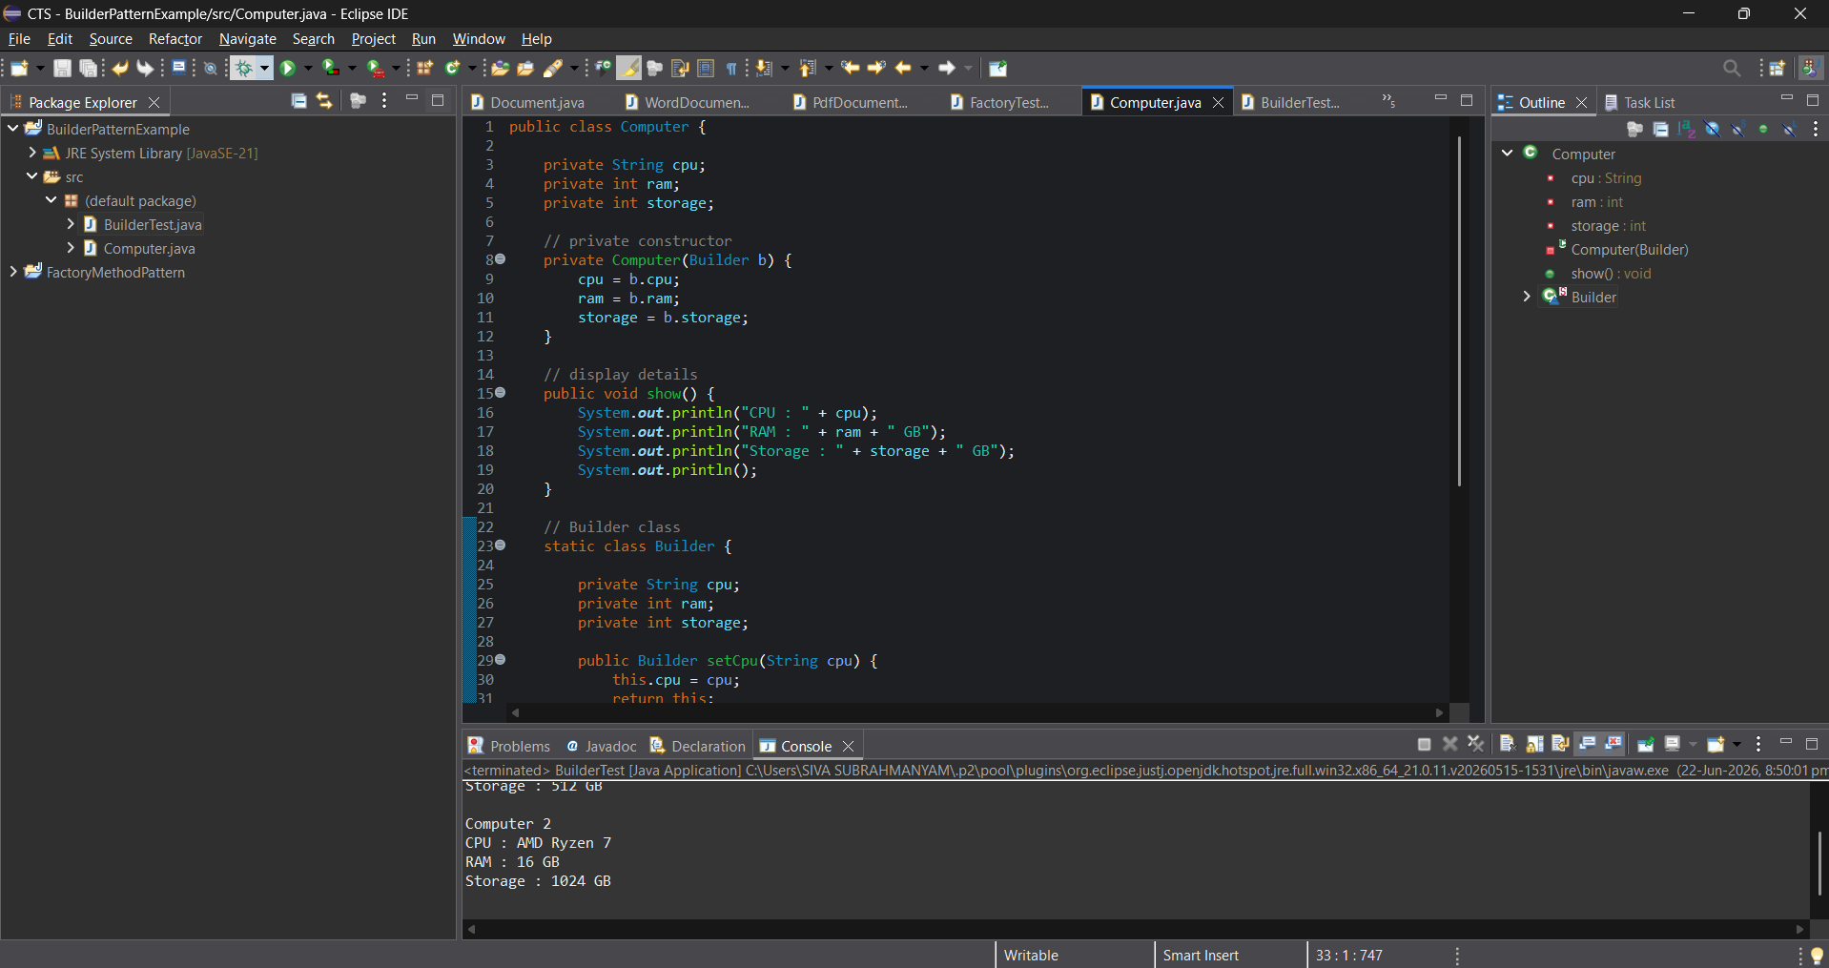
Description:
In this program, the Builder Design Pattern is used to create Computer objects with different configurations. A computer may contain multiple attributes such as CPU, RAM, and storage, and not every configuration needs to be the same. Instead of creating multiple constructors, the Builder pattern allows the object to be created step by step by setting only the required values. This makes the code more simple, readable, and easier to maintain when additional features are added in the future.
Exercise 4: Implementing the Adapter Pattern
Scenario:
You are developing a payment processing system that needs to integrate with multiple third-party payment gateways with different interfaces. Use the Adapter Pattern to achieve this.
Steps:
- Create a New Java Project:
  - Create a new Java project named AdapterPatternExample.
- Define Target Interface:
  - Create an interface PaymentProcessor with methods like processPayment().
- Implement Adaptee Classes:
  - Create classes for different payment gateways with their own methods.
- Implement the Adapter Class:
  - Create an adapter class for each payment gateway that implements PaymentProcessor and translates the calls to the gateway-specific methods.
- Test the Adapter Implementation:
  - Create a test class to demonstrate the use of different payment gateways through the adapter.
Exercise 5: Implementing the Decorator Pattern
Scenario:
You are developing a notification system where notifications can be sent via multiple channels (e.g., Email, SMS). Use the Decorator Pattern to add functionalities dynamically.
Steps:
- Create a New Java Project:
  - Create a new Java project named DecoratorPatternExample.
- Define Component Interface:
  - Create an interface Notifier with a method send().
- Implement Concrete Component:
  - Create a class EmailNotifier that implements Notifier.
- Implement Decorator Classes:
  - Create abstract decorator class NotifierDecorator that implements Notifier and holds a reference to a Notifier object.
  - Create concrete decorator classes like SMSNotifierDecorator, SlackNotifierDecorator that extend NotifierDecorator.
- Test the Decorator Implementation:
  - Create a test class to demonstrate sending notifications via multiple channels using decorators.

Exercise 6: Implementing the Proxy Pattern
Scenario:
You are developing an image viewer application that loads images from a remote server. Use the Proxy Pattern to add lazy initialization and caching.
Steps:
- Create a New Java Project:
  - Create a new Java project named ProxyPatternExample.
- Define Subject Interface:
  - Create an interface Image with a method display().
- Implement Real Subject Class:
  - Create a class RealImage that implements Image and loads an image from a remote server.
- Implement Proxy Class:
  - Create a class ProxyImage that implements Image and holds a reference to RealImage.
  - Implement lazy initialization and caching in ProxyImage.
- Test the Proxy Implementation:
  - Create a test class to demonstrate the use of ProxyImage to load and display images.
Exercise 7: Implementing the Observer Pattern
Scenario:
You are developing a stock market monitoring application where multiple clients need to be notified whenever stock prices change. Use the Observer Pattern to achieve this.
Steps:
- Create a New Java Project:
  - Create a new Java project named ObserverPatternExample.
- Define Subject Interface:
  - Create an interface Stock with methods to register, deregister, and notify observers.
- Implement Concrete Subject:
  - Create a class StockMarket that implements Stock and maintains a list of observers.
- Define Observer Interface:
  - Create an interface Observer with a method update().
- Implement Concrete Observers:
  - Create classes MobileApp, WebApp that implement Observer.
- Test the Observer Implementation:
  - Create a test class to demonstrate the registration and notification of observers.
Exercise 8: Implementing the Strategy Pattern
Scenario:
You are developing a payment system where different payment methods (e.g., Credit Card, PayPal) can be selected at runtime. Use the Strategy Pattern to achieve this.
Steps:
- Create a New Java Project:
  - Create a new Java project named StrategyPatternExample.
- Define Strategy Interface:
  - Create an interface PaymentStrategy with a method pay().
- Implement Concrete Strategies:
  - Create classes CreditCardPayment, PayPalPayment that implement PaymentStrategy.
- Implement Context Class:
  - Create a class PaymentContext that holds a reference to PaymentStrategy and a method to execute the strategy.
- Test the Strategy Implementation:
  - Create a test class to demonstrate selecting and using different payment strategies.
Exercise 9: Implementing the Command Pattern
Scenario: You are developing a home automation system where commands can be issued to turn devices on or off. Use the Command Pattern to achieve this.
Steps:
- Create a New Java Project:
  - Create a new Java project named CommandPatternExample.
- Define Command Interface:
  - Create an interface Command with a method execute().
- Implement Concrete Commands:
  - Create classes LightOnCommand, LightOffCommand that implement Command.
- Implement Invoker Class:
  - Create a class RemoteControl that holds a reference to a Command and a method to execute the command.
- Implement Receiver Class:
  - Create a class Light with methods to turn on and off.
- Test the Command Implementation:
  - Create a test class to demonstrate issuing commands using the RemoteControl.
Exercise 10: Implementing the MVC Pattern
Scenario:
You are developing a simple web application for managing student records using the MVC pattern.
Steps:
- Create a New Java Project:
  - Create a new Java project named MVCPatternExample.
- Define Model Class:
  - Create a class Student with attributes like name, id, and grade.
- Define View Class:
  - Create a class StudentView with a method displayStudentDetails().
- Define Controller Class:
  - Create a class StudentController that handles the communication between the model and the view.
- Test the MVC Implementation:
  - Create a main class to demonstrate creating a Student, updating its details using StudentController, and displaying them using StudentView.

Exercise 11: Implementing Dependency Injection
Scenario:
You are developing a customer management application where the service class depends on a repository class. Use Dependency Injection to manage these dependencies.
Steps:
- Create a New Java Project:
  - Create a new Java project named DependencyInjectionExample.
- Define Repository Interface:
  - Create an interface CustomerRepository with methods like findCustomerById().
- Implement Concrete Repository:
  - Create a class CustomerRepositoryImpl that implements CustomerRepository.
- Define Service Class:
  - Create a class CustomerService that depends on CustomerRepository.
- Implement Dependency Injection:
  - Use constructor injection to inject CustomerRepository into CustomerService.
- Test the Dependency Injection Implementation:
  - Create a main class to demonstrate creating a CustomerService with CustomerRepositoryImpl and using it to find a customer.

